Name - ocpp_tag

Url -  [http://3.7.65.129:8080/api/](http://localhost:8080/api/state)ocpp_tag

Method – GET   
Operation – GET ALL ocpp  
Body - NULL

Example -   
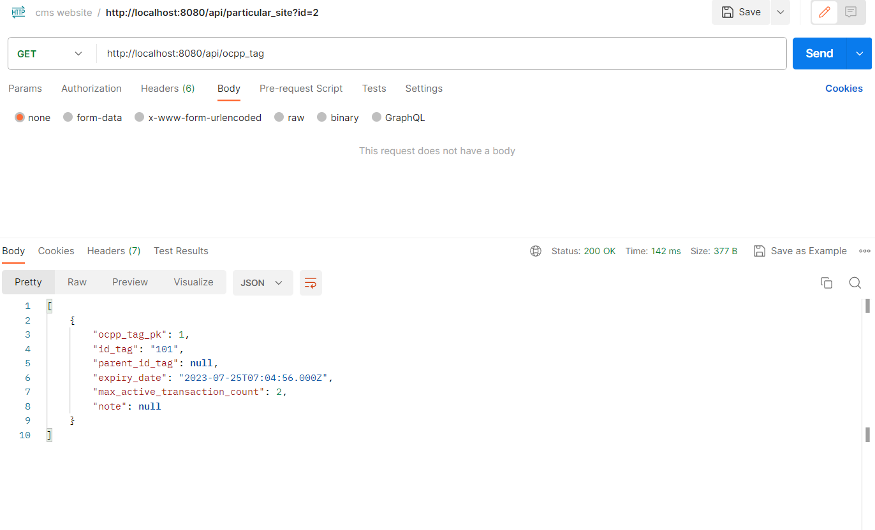

Method – POST   
Operation – CREATE  
Body – In JSON  
{  
“id_key”:” ” 🡪 necessary  
}

Example -   
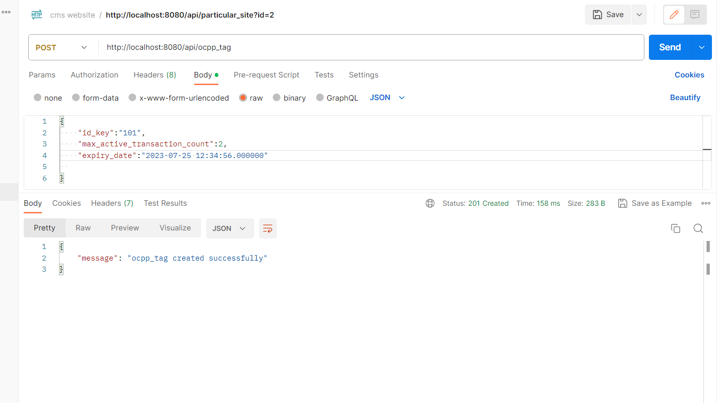  
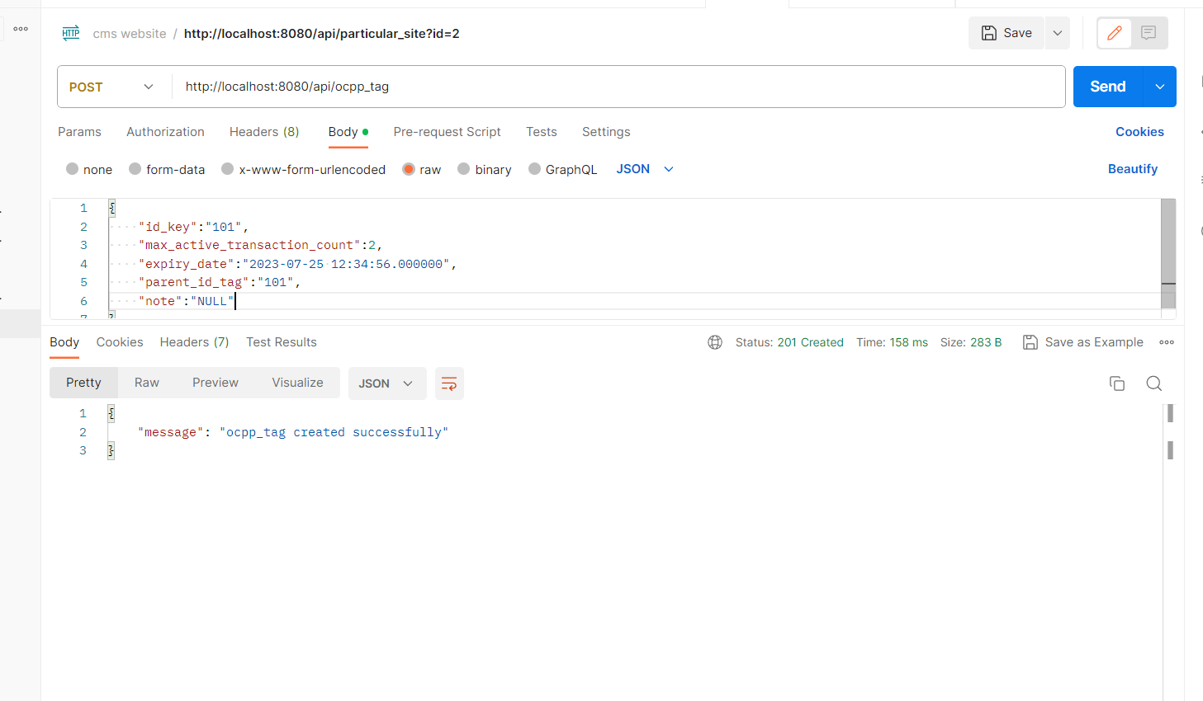

Method – DELETE  
Operation – DELETE ocpp  
Body - In JSON  
{  
“id”:”1”

}

Example -   
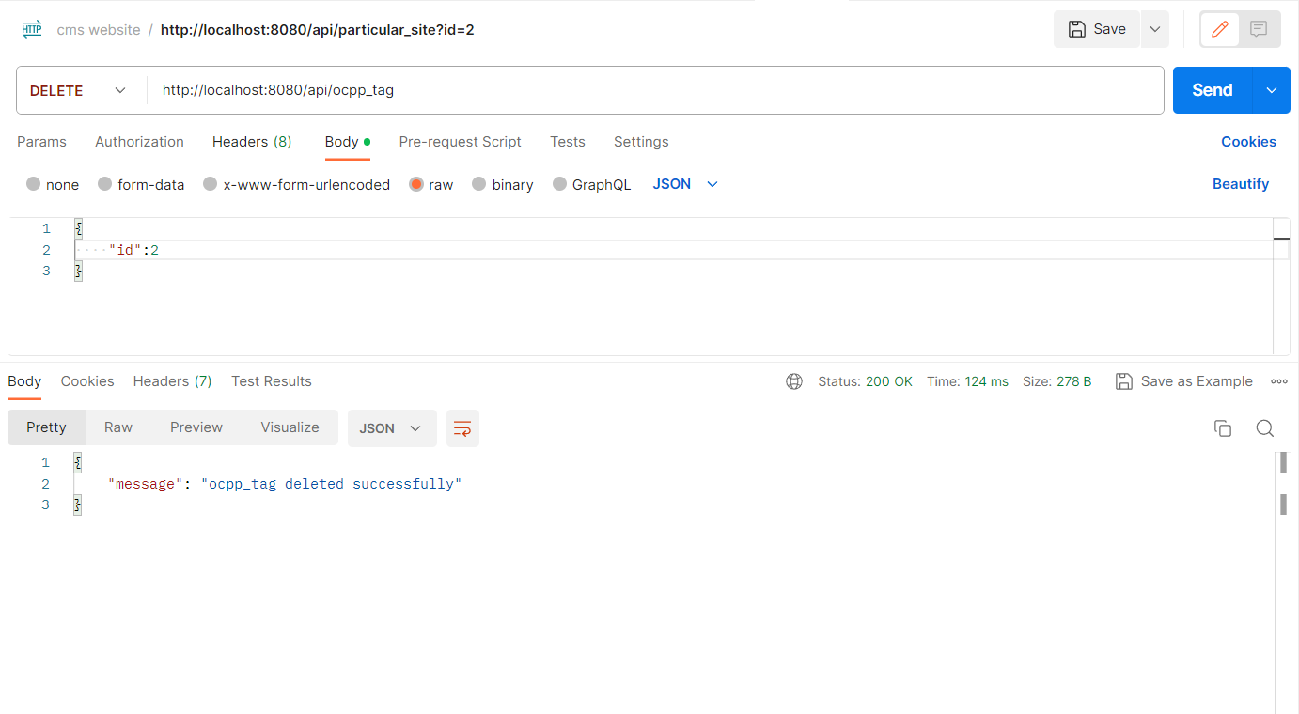

-------------------------------------------------------------------------------------------------------------

Name - variant

Url - <http://3.7.65.129:8080/api/variant>

Method – GET   
Operation – GET ALL VARIANT  
Body - NULL

Example -   
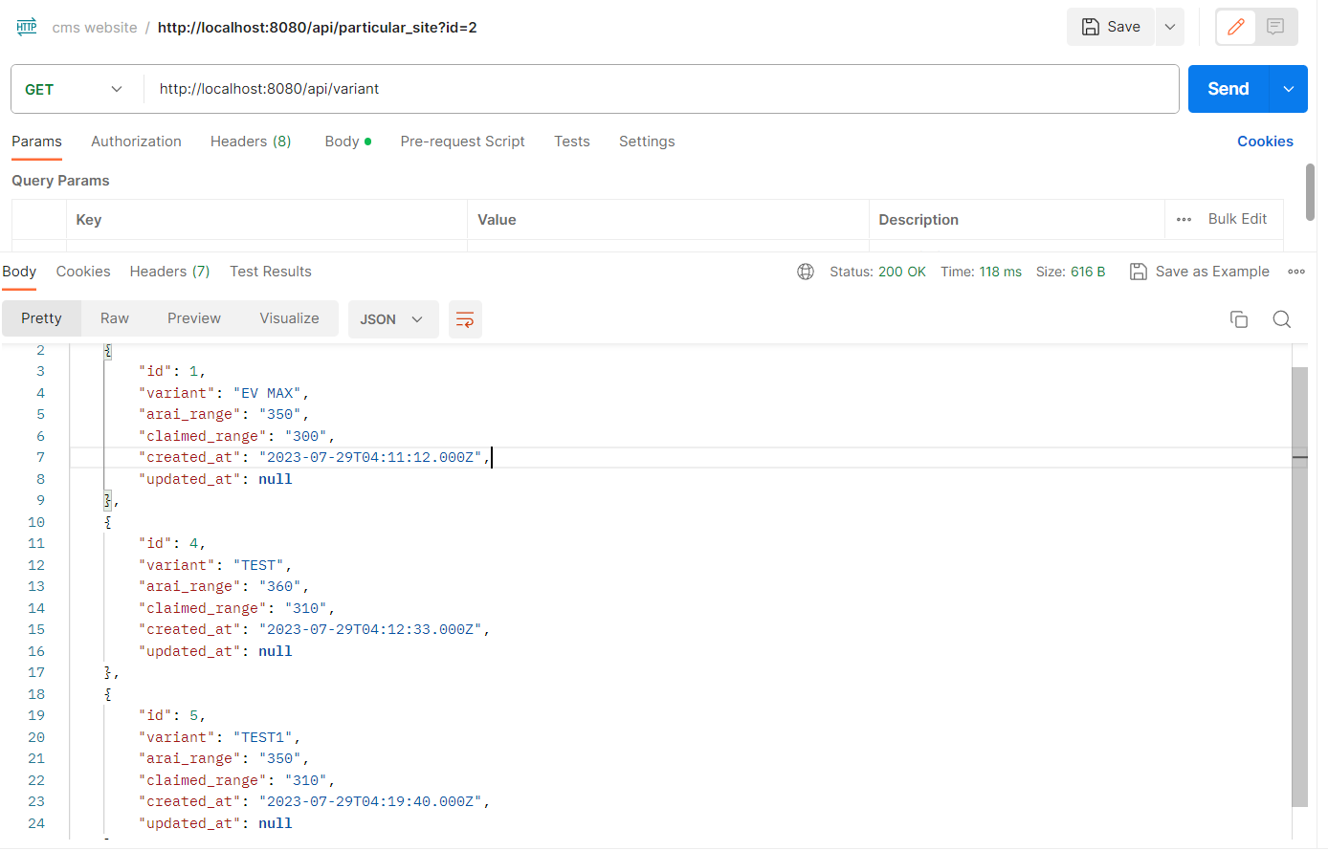

Method – POST   
Operation – CREATE  
Body – In JSON  
{  
variant,arai_range,claimed_range  
}

Example -   
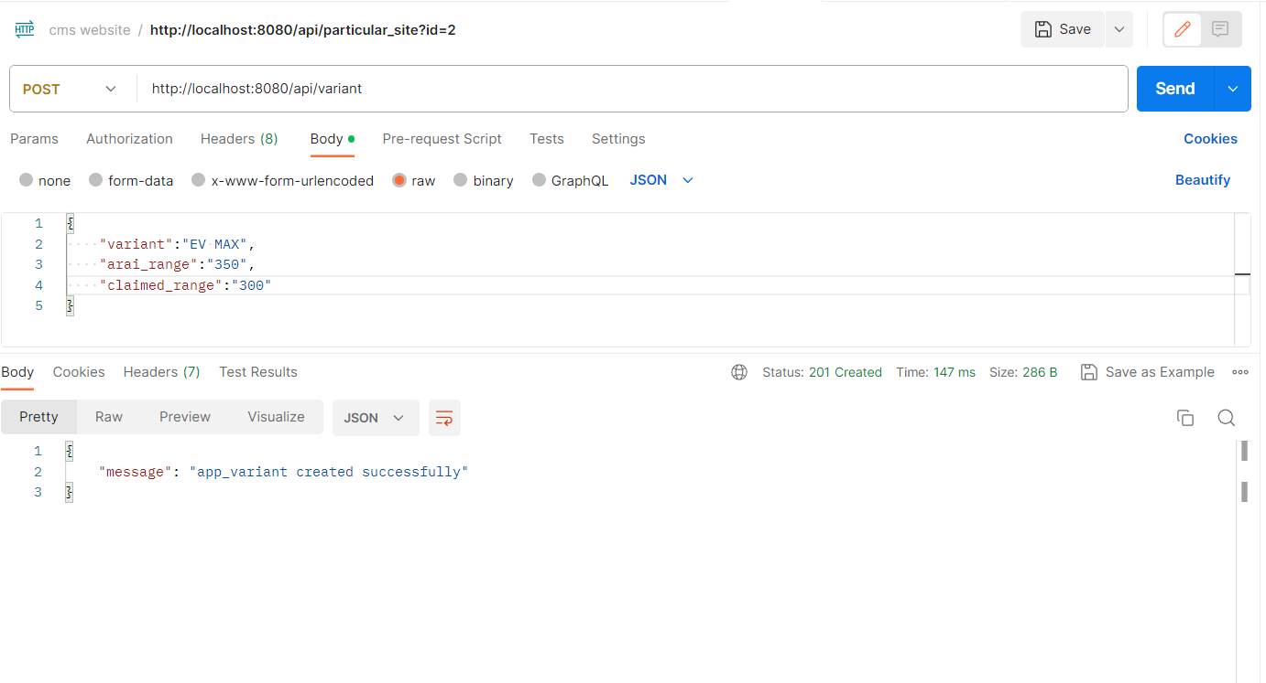

Method – DELETE  
Operation – DELETE VARIANT  
Body - In JSON  
{  
“id”:”1”

}

Example -   
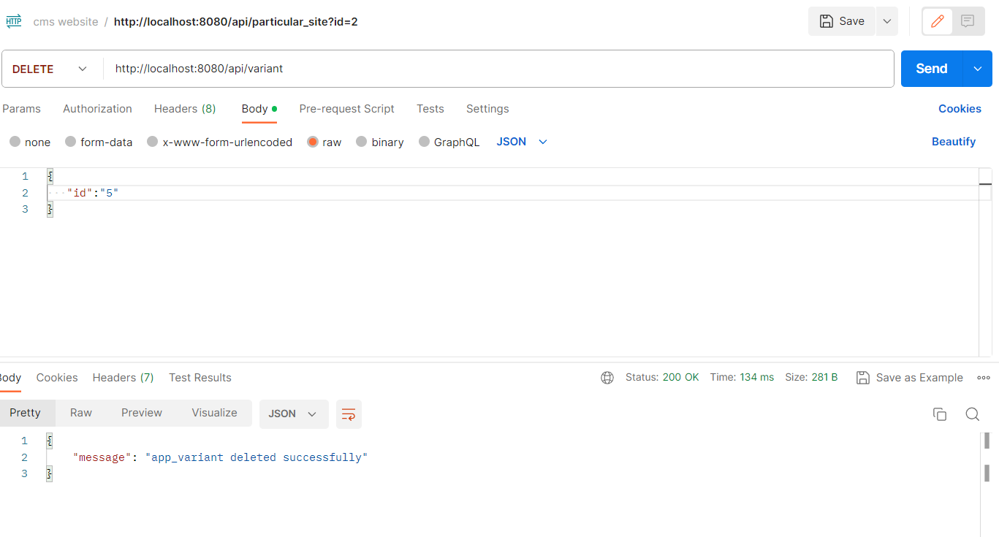

---------------------------------------------------------------------------------------------------

Name - VEHICLE

Url - <http://3.7.65.129:8080/api/vehicle>

Method – GET   
Operation – GET ALL VEHICLES  
Body - NULL

Example -   
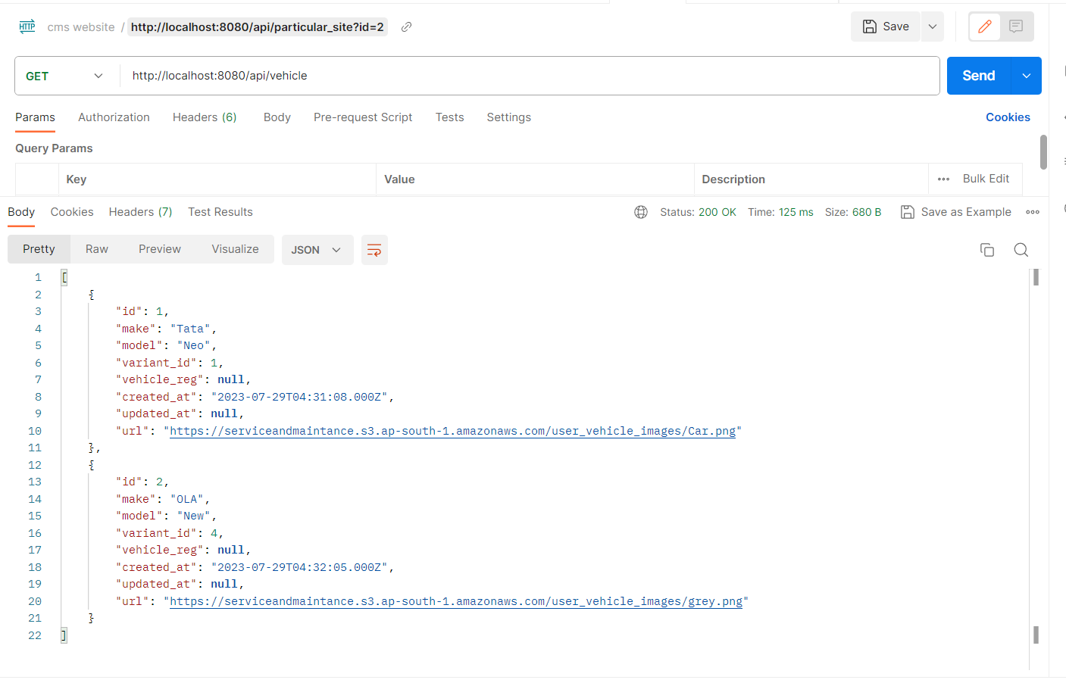

Method – POST   
Operation – CREATE  
Body – In JSON  
{  
make,model,variant_id,vehicle_reg  
}

Example -   
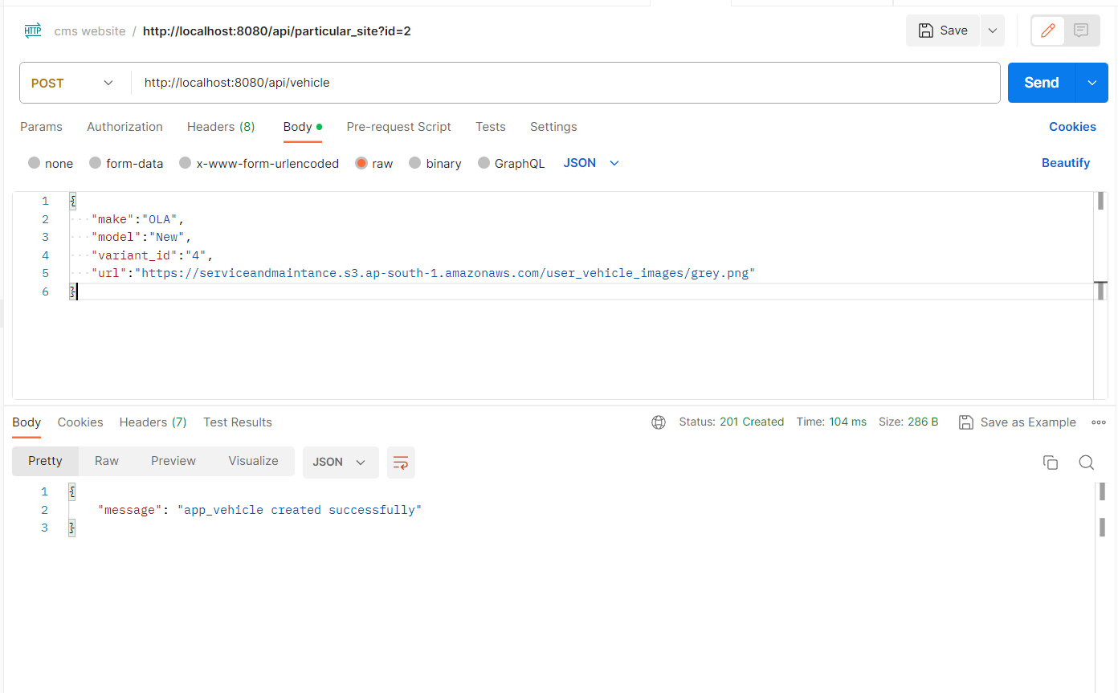

Method – DELETE  
Operation – DELETE VEHICLE  
Body - In JSON  
{  
“id”:”3”

}

Example -   
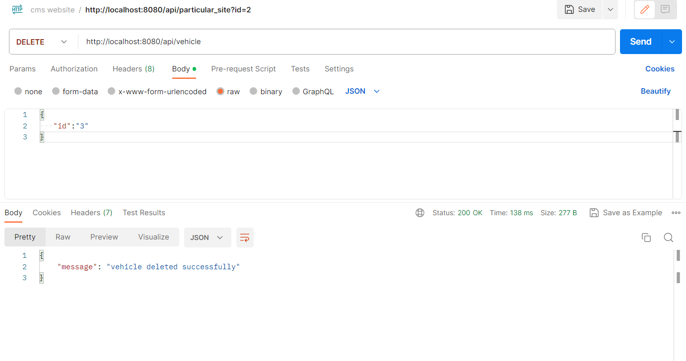

---------------------------------------------------------------------------------------------------

Method – get  
Operation – Get make  
Url - <http://3.7.65.129:8080/api/getmake>

Example -   
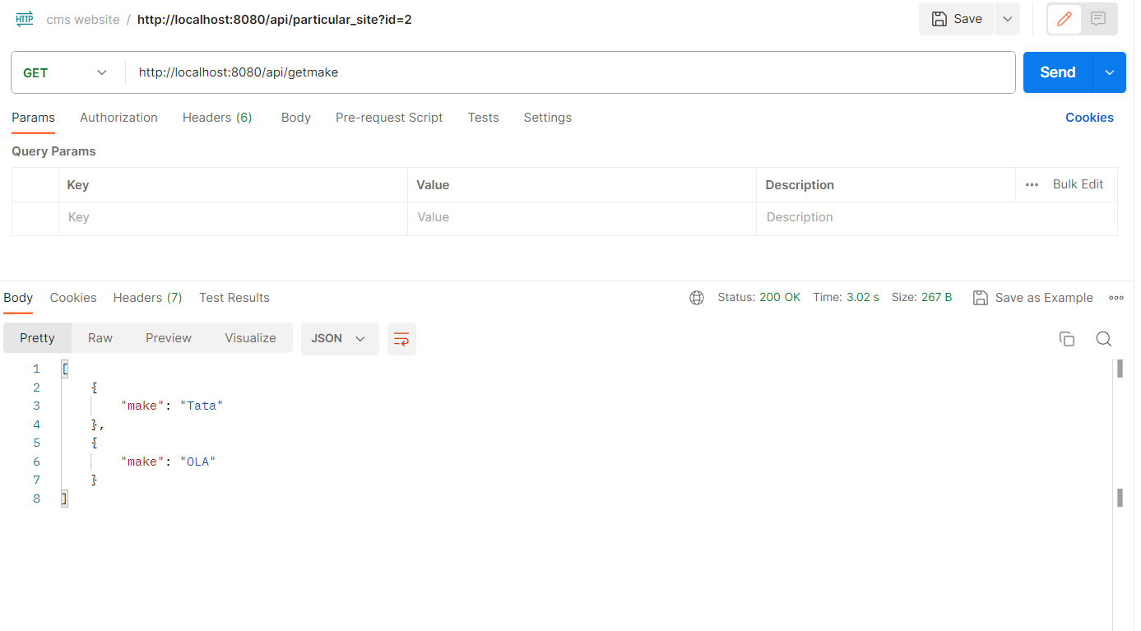

Method – get  
Operation – Get model  
Url - <http://3.7.65.129:8080/api/getmodel?make=OLA>

Example -

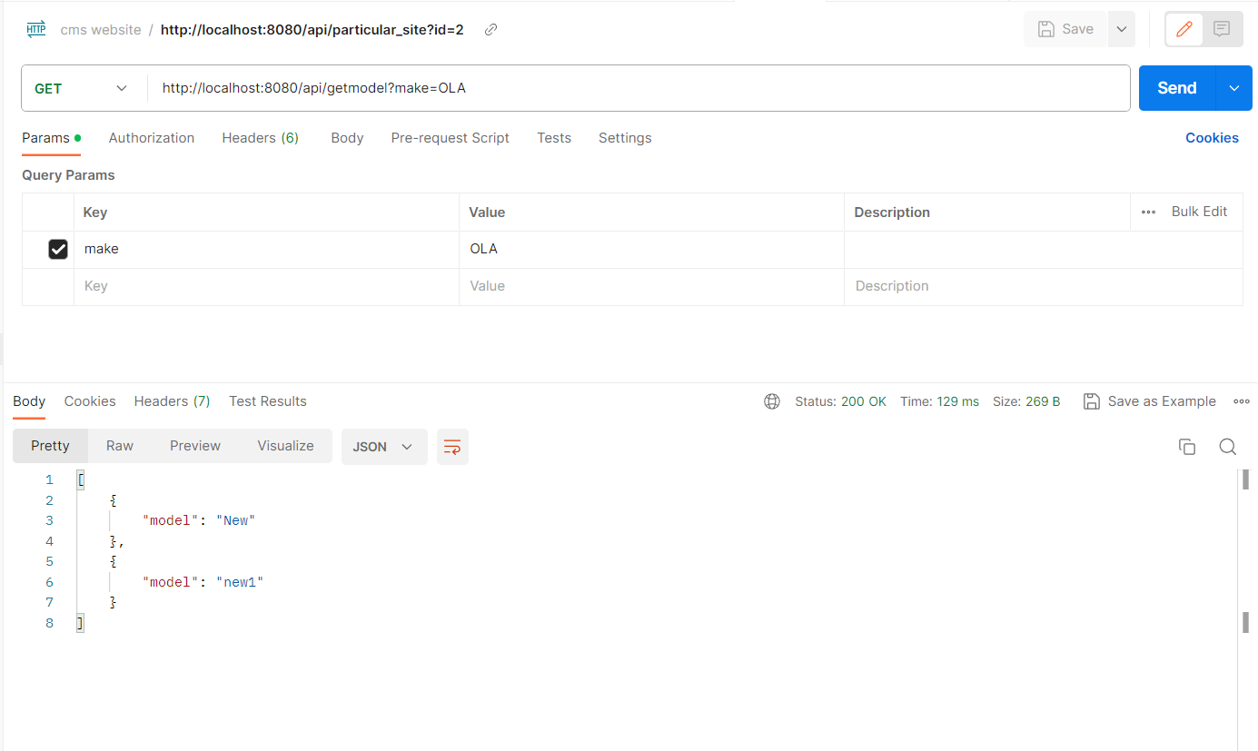

Method – get  
Operation – Get variant  
Url - <http://3.7.65.129:8080/api/getvariant?model=new1>

Example -   
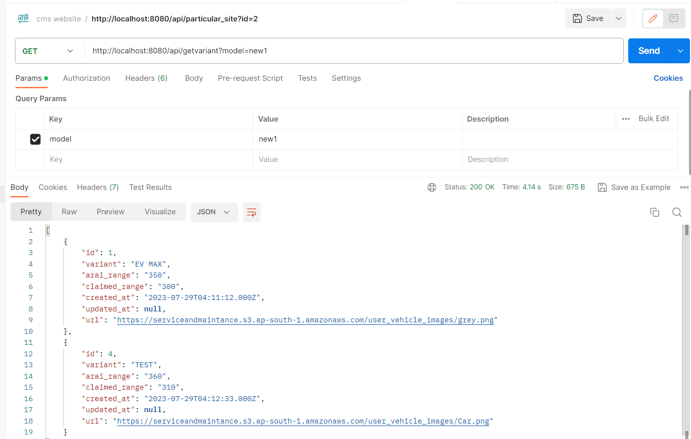

Method – get  
Operation – Get variant by id  
Url - <http://3.7.65.129:8080/api/variant/1>

Example -   
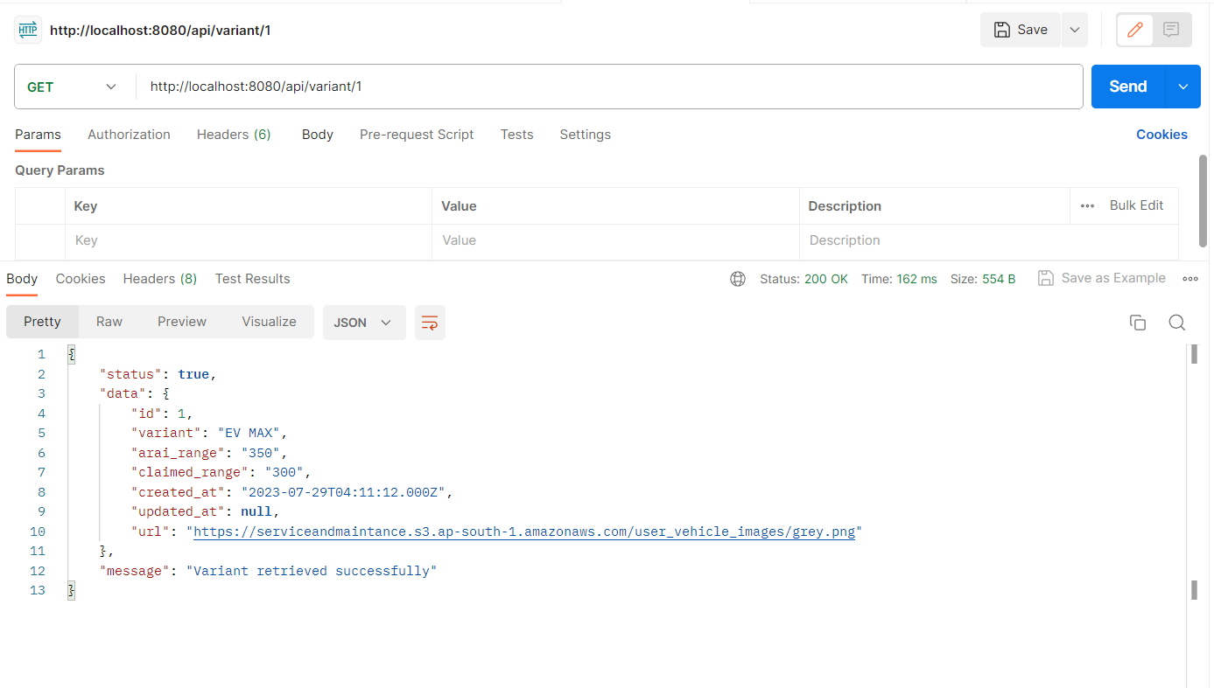

---------------------------------------------------------------------------------------------------

Method – get  
Operation – Get user  
Url - <http://3.7.65.129:8080/api/user>

Example -   
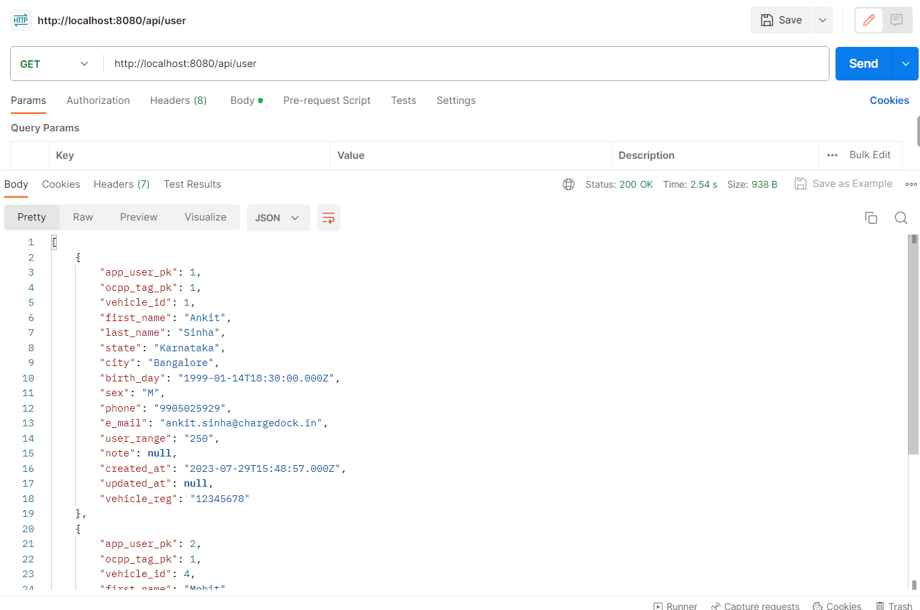

Method – POST  
Operation – Add User information as well as user  
Url - <http://3.7.65.129:8080/api/user>  
params : ocpp_tag_pk,vehicle_id,first_name,last_name,state,city,birth_day,gender,phone,e_mail,user_range,  
note,vehicle_reg  
  
note, vehicle_reg and user_range are not passed if user set null  
body in json :

{

    "ocpp_tag_pk":"1",

    "vehicle_id":"4",

    "first_name":"Mohit",

    "last_name":"Sinha",

    "state":"Karnataka",

    "city":"Bangalore",

    "birth_day":"1999-01-15",

    "sex":"Male",

    "phone":"1234567890",

    "e_mail":"ankit.sinha@chargedock.in",

    "user_range":"250",

    "vehicle_reg":"12345678"

}

Example - sex is updated to gender  
  
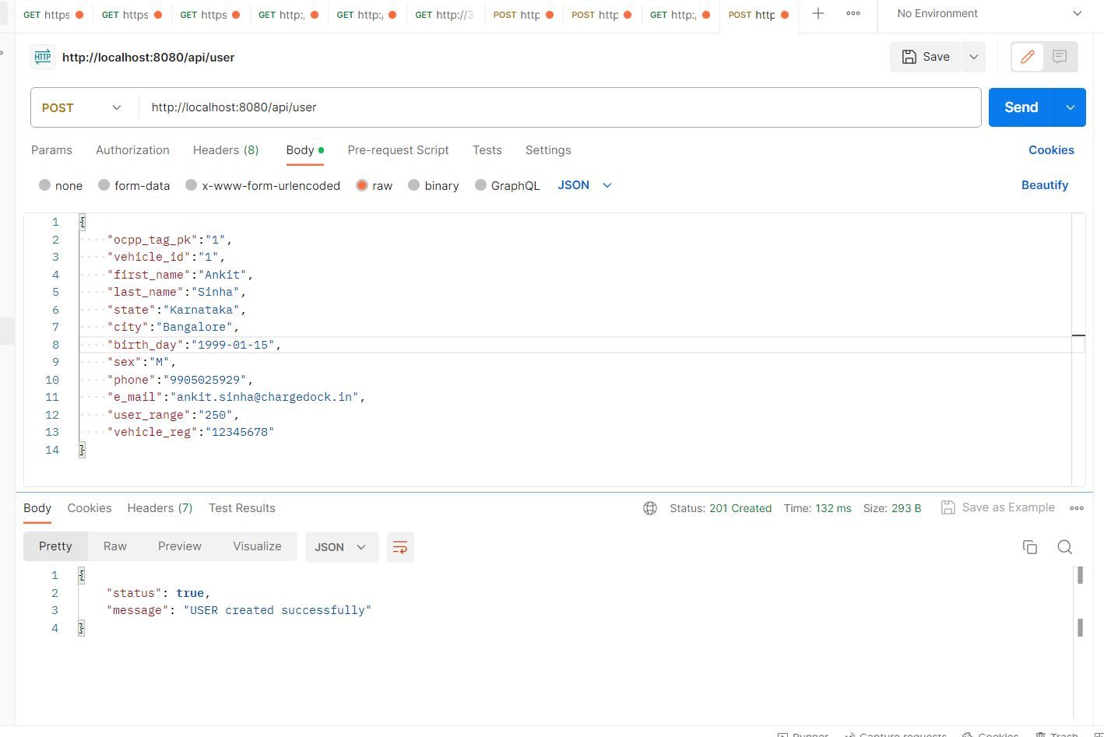

Method – delete  
Operation – Delete user  
Url - <http://3.7.65.129:8080/api/user>

Example -   
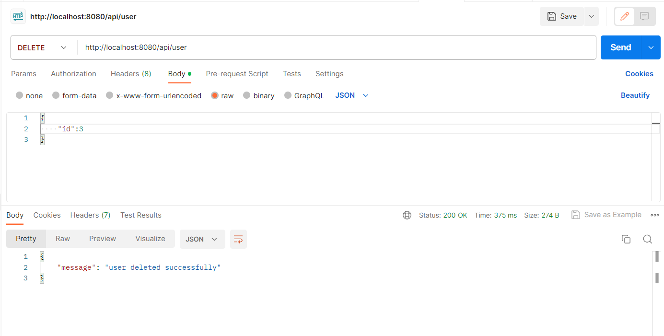

---------------------------------------------------------------------------------------------------

Method – Get  
Operation – check phone is registered or not  
Url - <http://3.7.65.129:8080/api/isregister?phone=1234567890>

Example -   
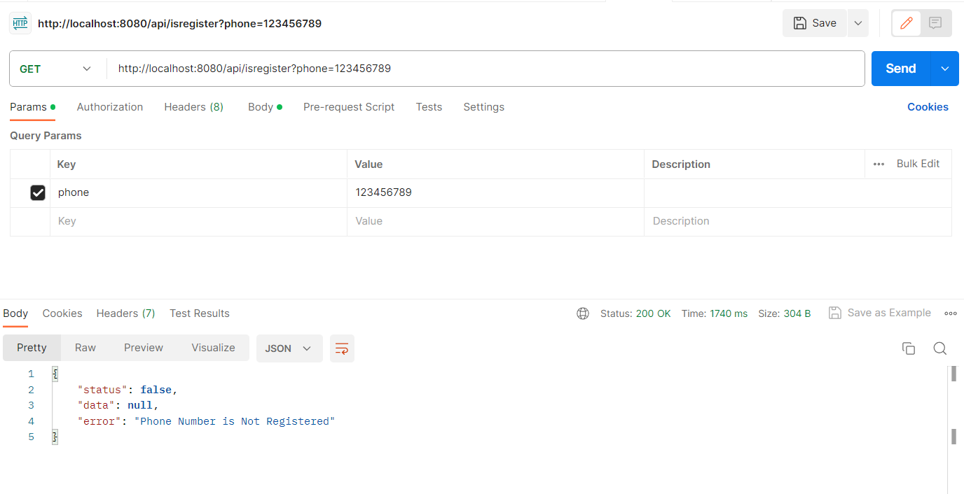

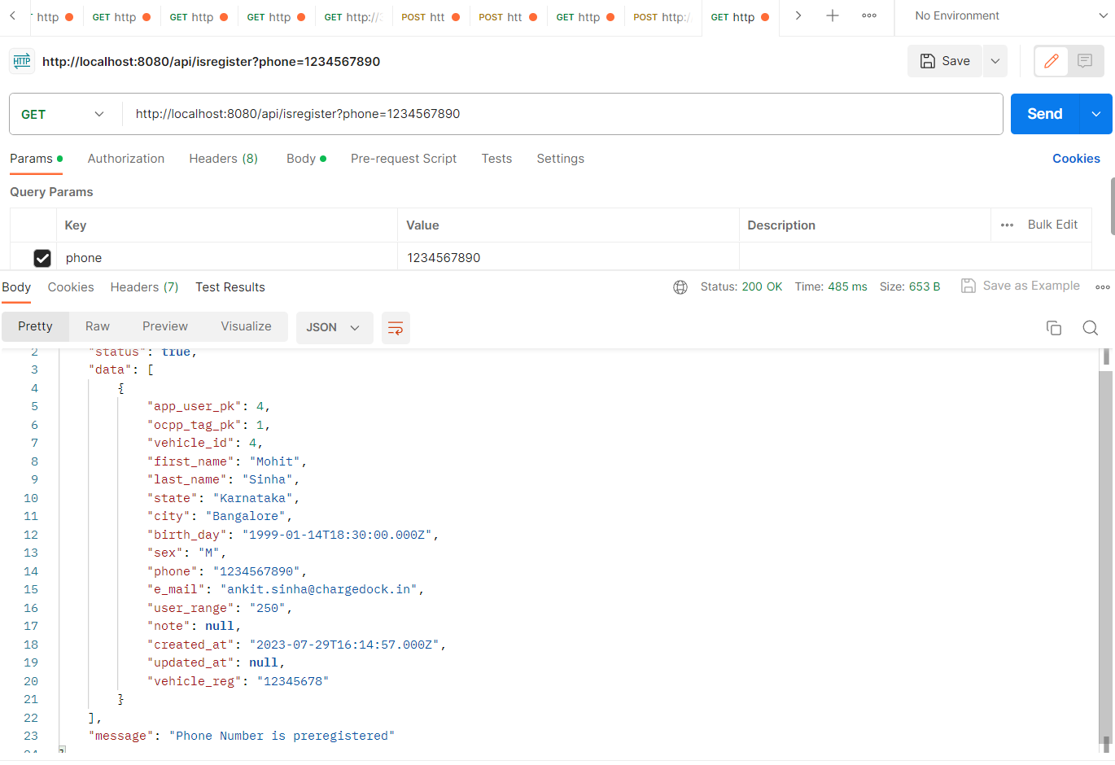  
---------------------------------------------------------------------------------------------------

Method – POST  
Operation – Add state and city   
Url - <http://3.7.65.129:8080/api/app_state_city>

Body in json: {state,city}

Example -   
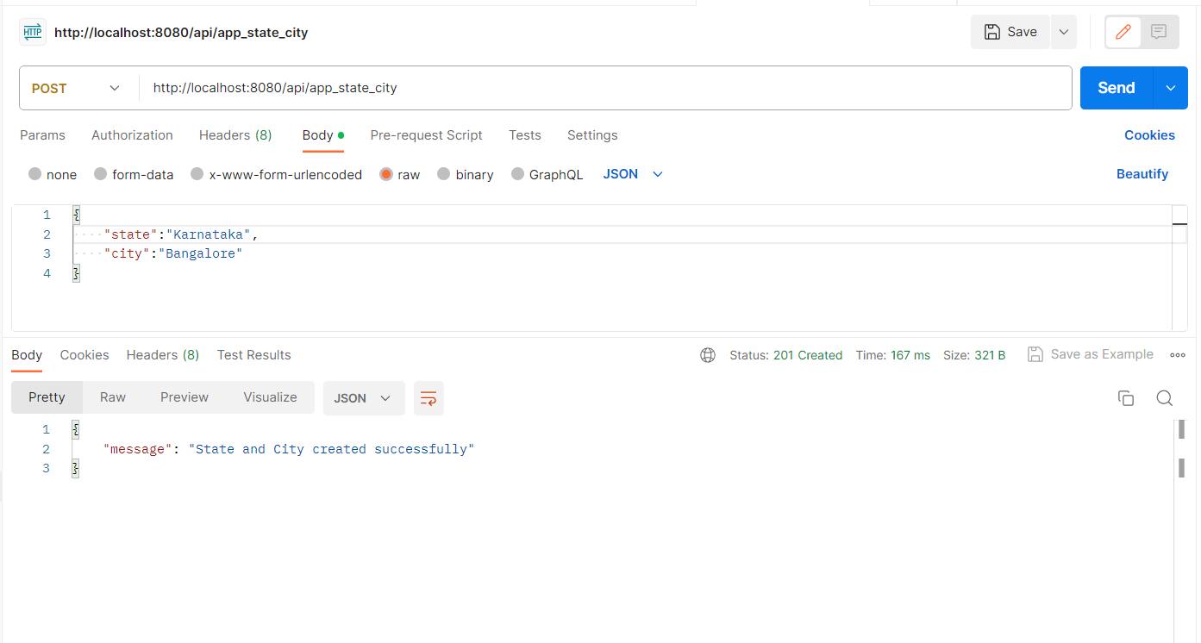

Method – GET  
Operation – view all state and city   
Url - <http://3.7.65.129:8080/api/app_state_city>

Body in json: None

Example -   
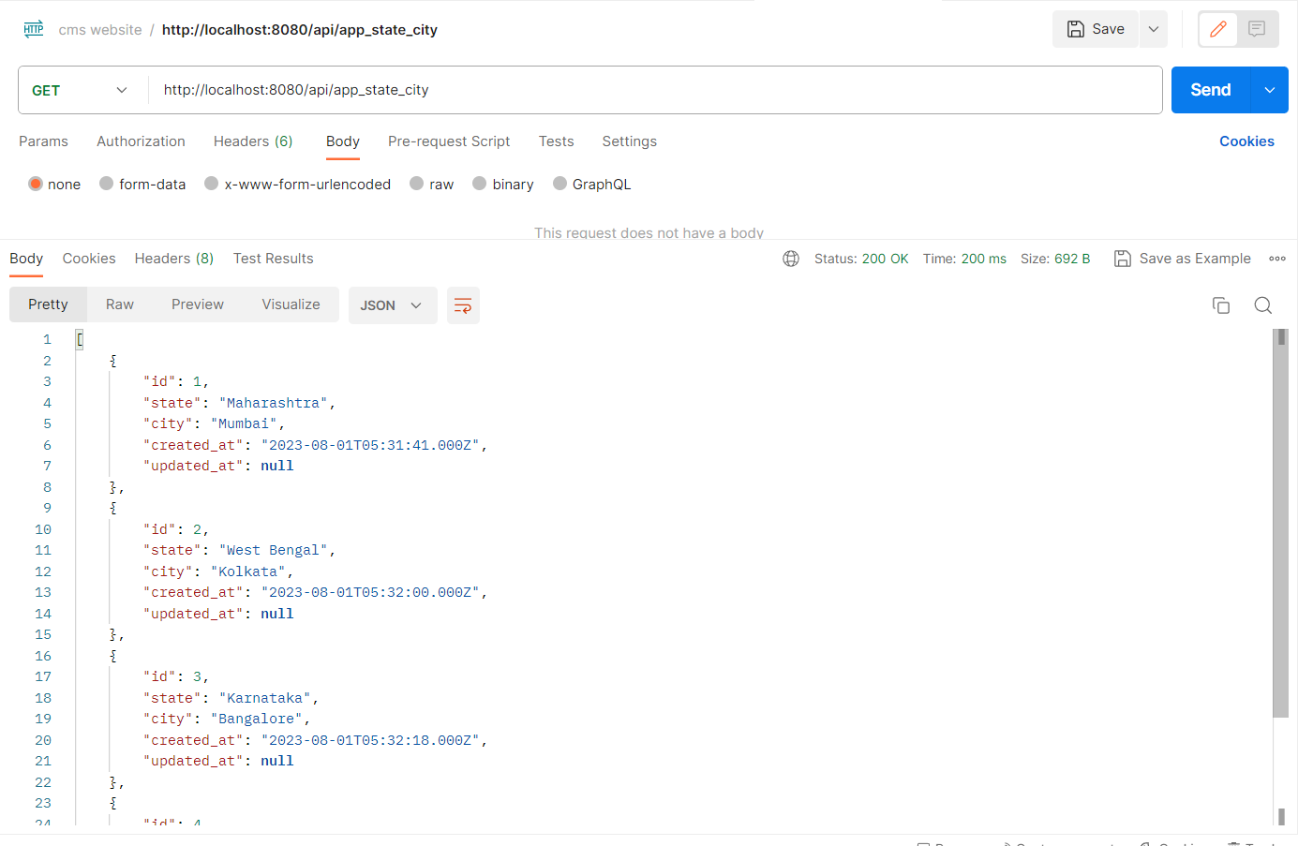

Method – DELETE  
Operation – delete a state and city   
Url - <http://3.7.65.129:8080/api/app_state_city>

Body in json: { id }

Example -   
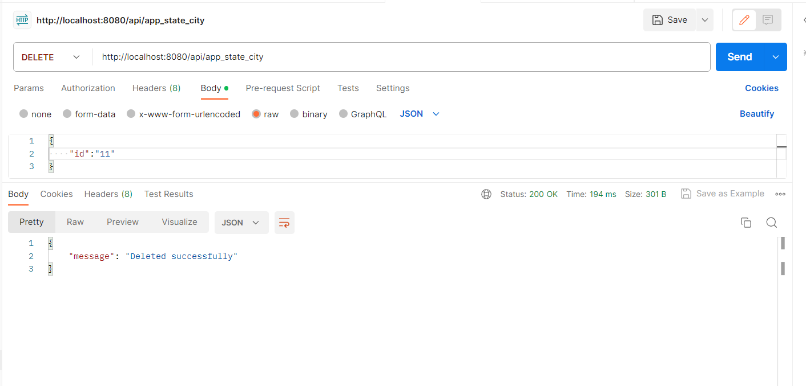

---------------------------------------------------------------------------------------------------

Method – GET  
Operation – Get state   
Url - <http://3.7.65.129:8080/api/app_state>

Example -   
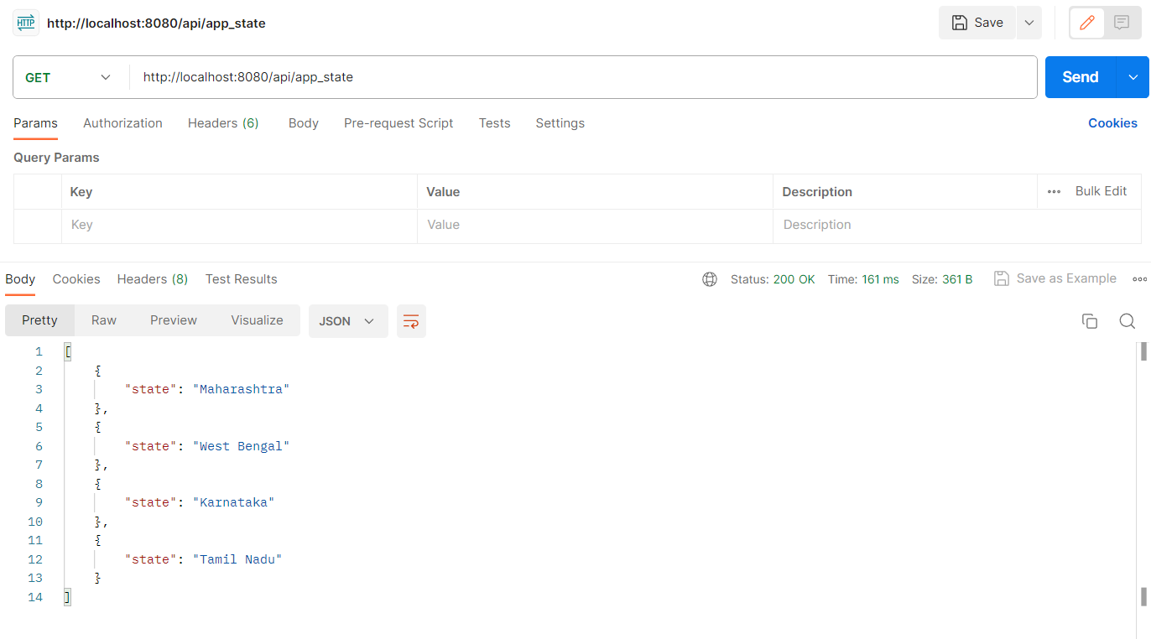

Method – GET  
Operation – Get city   
Url - <http://3.7.65.129:8080/api/app_city?state=karnataka>

Example -   
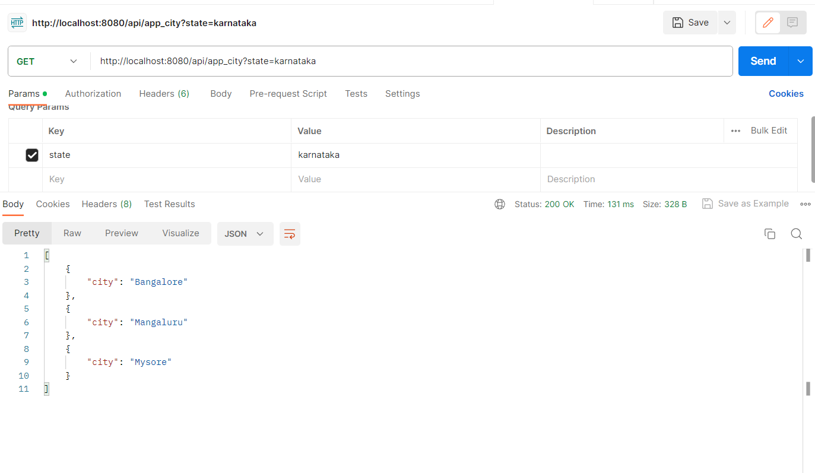

---------------------------------------------------------------------------------------------------

Name – User vehicle

Url - <http://3.7.65.129:8080/api/uservehicle>

Method – POST  
Operation – Add user vehicle

Body in json: {

    "make":"Tata",

    "model":"Neo",

    "variant_id":"4",

    "app_user_pk":"10"

}

Example -   
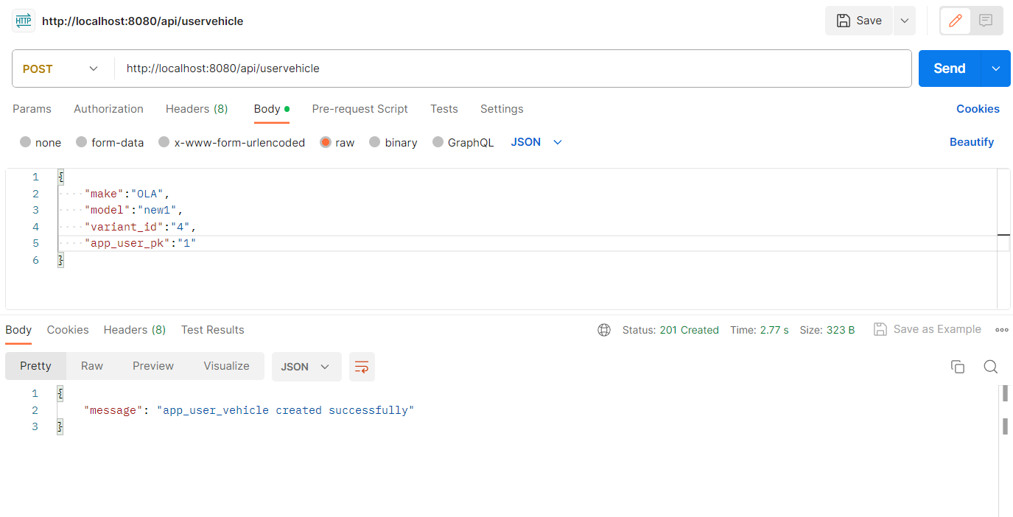

Method – GET  
Operation – view all vehicle associated to a user   
url - <http://3.7.65.129:8080/api/uservehicle?user_id=10>

Body in json: None

Example -   
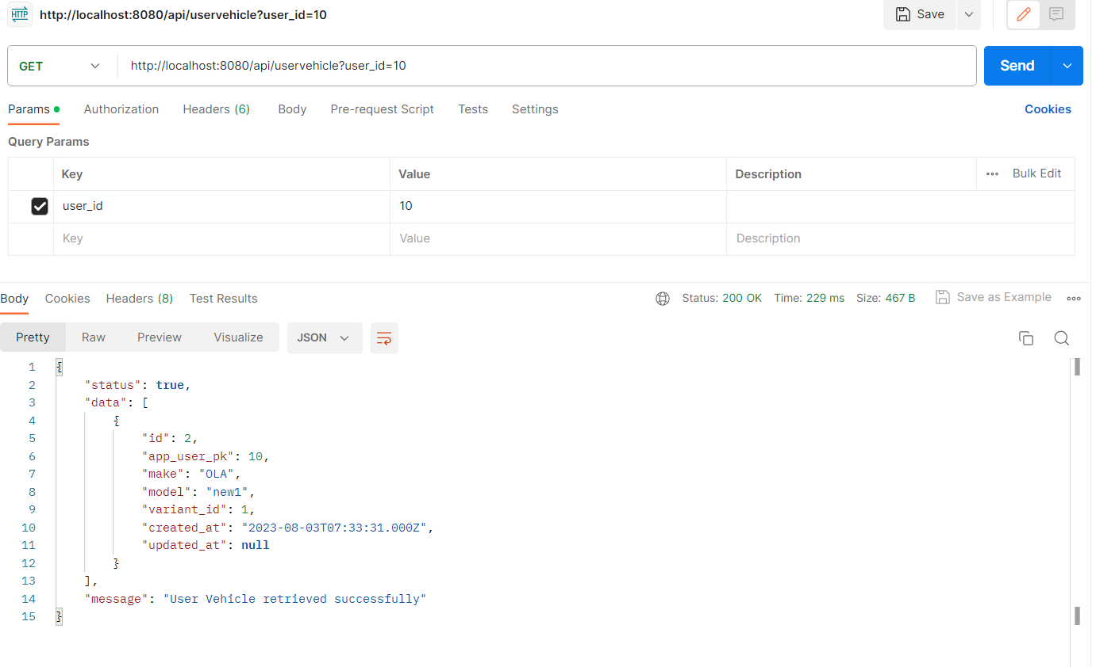

Update the above api by adding some more fields :

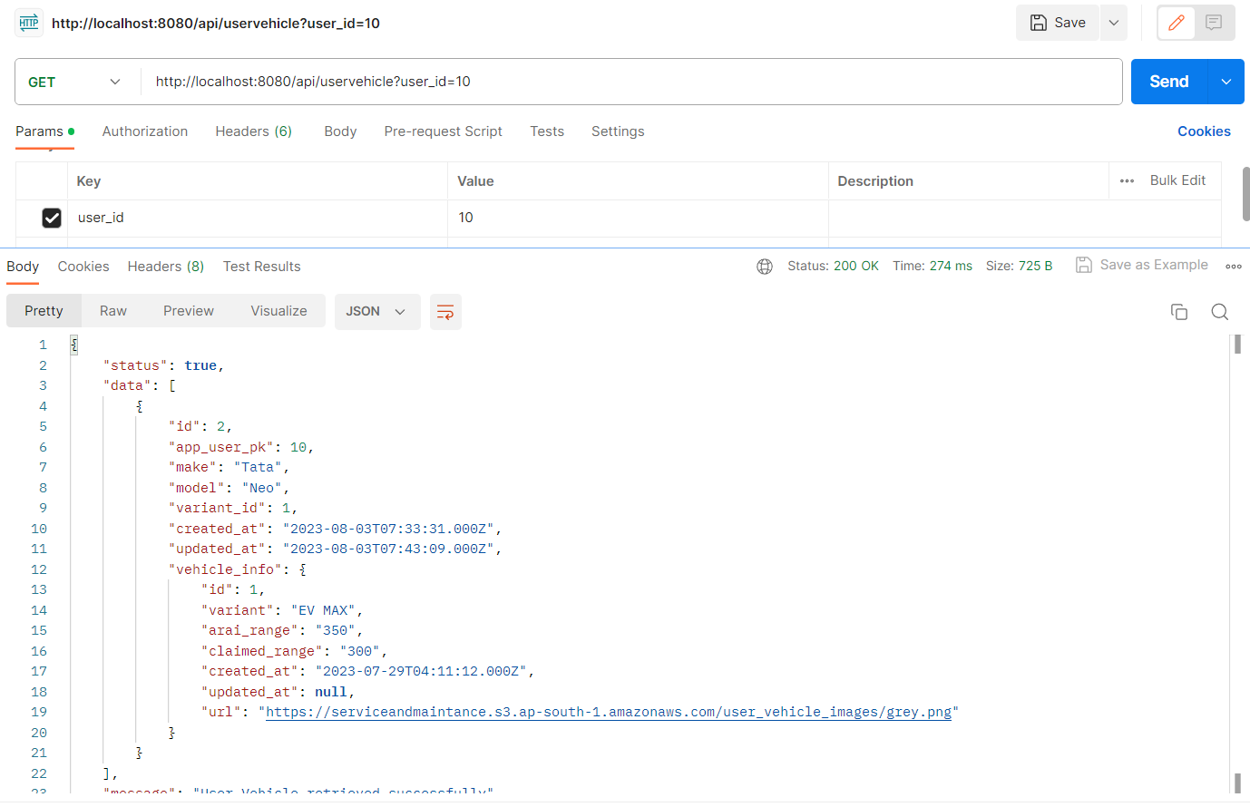

Method – DELETE  
Operation – delete a user vehicle

Body in json: { id }

Example -   
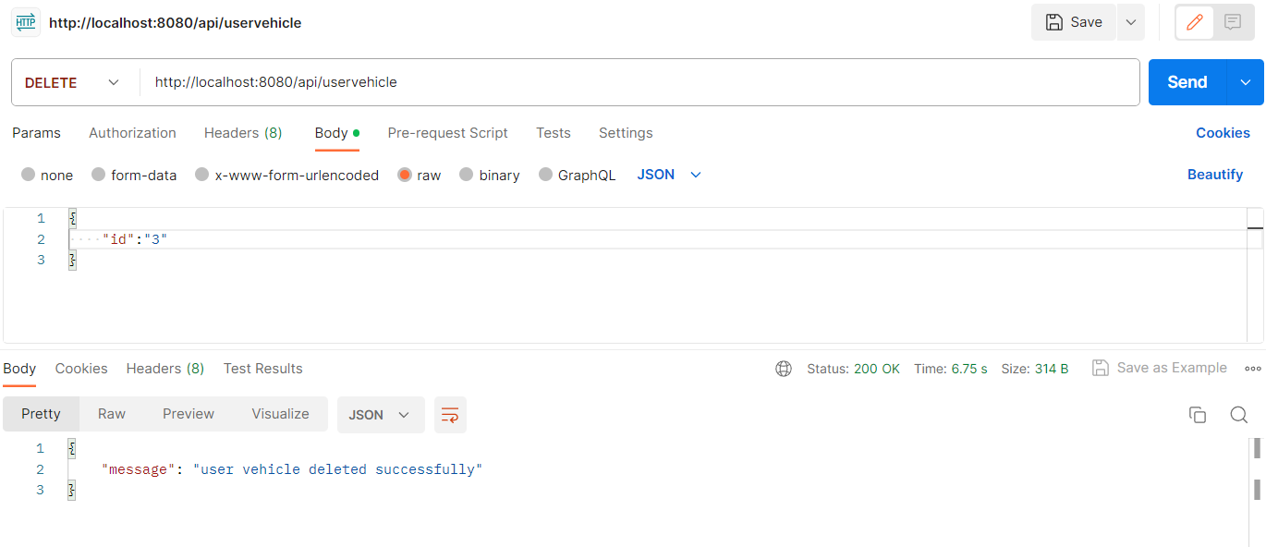

Method – PATCH  
Operation – update a user vehicle

Body in json: {

    "id":"2",

    "make":"Tata",

    "model":"Neo",

    "variant_id":"4",

    "app_user_pk":"10"

}

Example -   
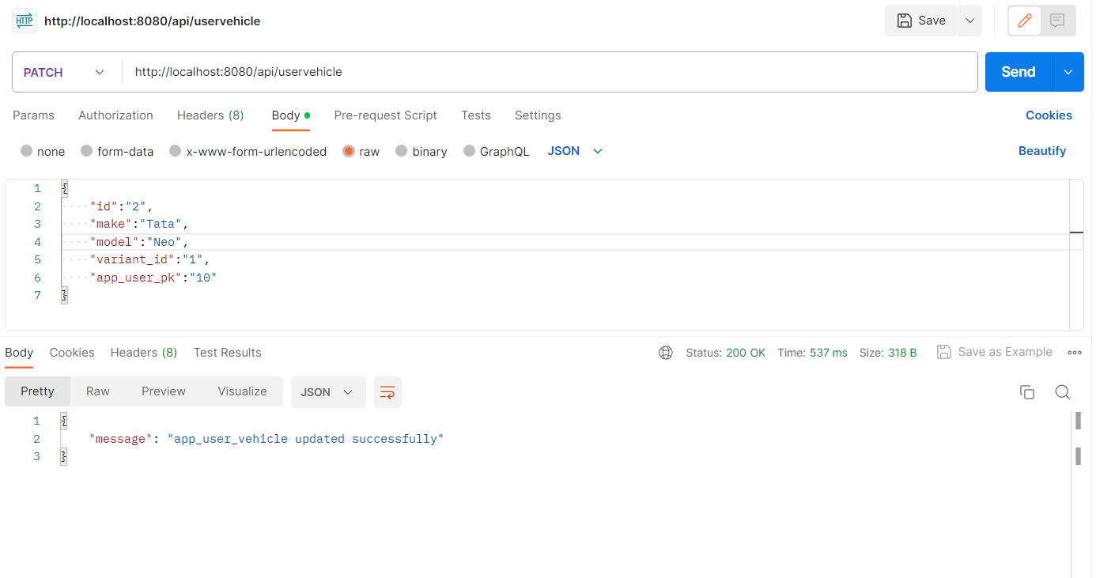

url – Base_url + /api/user

Method – PATCH  
Operation – update a user personal information

Body in json: {

    "userId":"22",

    "first_name":"Update",

    "last_name":"Test",

    "state":"Bihar",

    "city":"Patna",

    "birth_day":"2000-08-07",

    "gender":"Male",

    "phone":"1212121345",

    "e_mail":"test@gmail.com"

}

Example -   
